Acting Up!

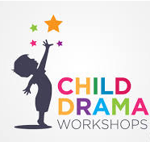

Primary School children participating in drama class:

“Enjoy school more”

“Have improved speaking and listening skills”

“Experience a marked increase in self-esteem in class”

“Recognise the value of working with others to achieve goals”

Source: Guardian Oct 2004 – Report by the Social Research Unit at the Institute of Education

Drama After-School Club starts at Oaklands Junior School in September!!

Successfully operating in Bracknell Forest & Wokingham Boroughs,
Classes are run by Amanda Russell,
Graduate of the Italia Conti Academy of Theatre Arts

Limited to 20 pupils at £6.50 per pupil per lesson for a 12-week programme starting Wednesday 18th September. Alternative day could be made available instead, based on demand.

To book a place, or for further details, please call Amanda on 07905 477583 or email: russell.amanda112@gmail.com

