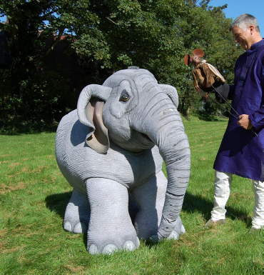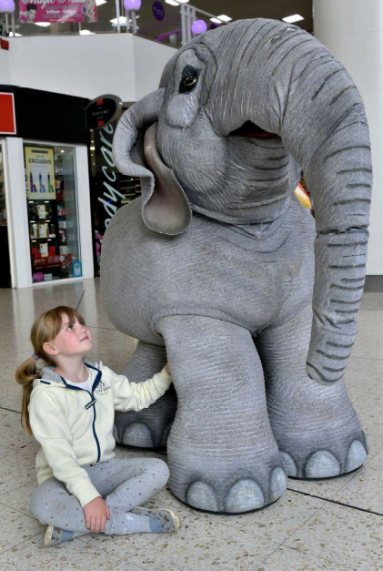
Adambara and Zhim
Thursday 30th May
10:30-11:30am
Bracknell Library
‘Adambara and Zhim’ is a charming, whimsical show based on the traditional Indian Panchatantra story of the Elephant and the mouse. The story is told by our narrator and mouse Zhim and encourages audience interaction and participation. Through enchanting puppetry and storytelling we see how the two creatures learn to live side by side in harmony and how a tiny mouse helped the elephants to survive. Suitable for children 3 years + £3 per ticket.
Book your place at Bracknell Library
01344 423149 email Bracknell.Library@bracknell-forest.gov.uk

