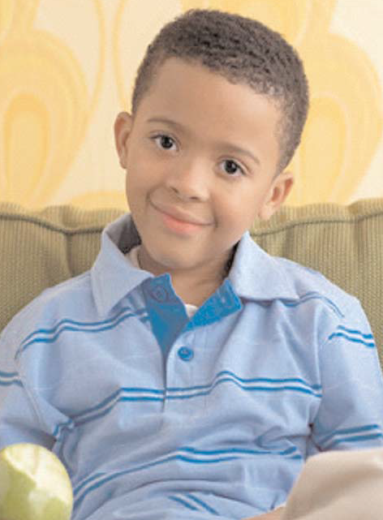
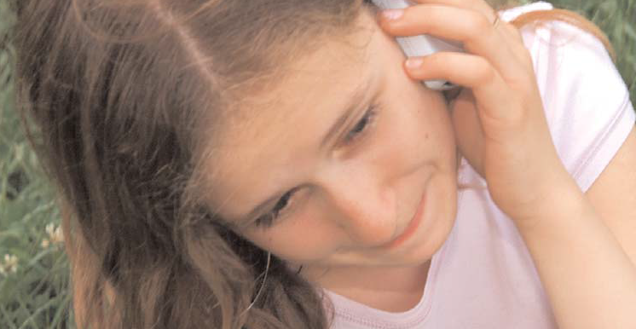
Evening Course

Incredible Years parenting course
Help for parents with challenging 4 to 11 yr olds

Parenting is probably the hardest job an adult will undertake, but also the one for which the least amount of training and preparation is provided. Why not attend an Incredible Years Parenting course. This effective, practical and intensive course covers the following topics:

- Does your child argue with adults as well as their peers?
- Is your child unwilling to accept and follow adults’ requests or rules?
- Is your child touchy / irritable and often annoyed by others?
- Does your child blame other people for their mistakes / misbehaviour?
- Do you spend more time telling them off than having fun with them?
- Are you feeling worried or stressed and wondering if things will ever get easier?

Evening sessions – Tuesday 23rd April – Tuesday 17th July 2019
(Excluding May Half Term)
7pm – 9pm
Venue: Bearwood Primary School, Bearwood Road, Wokingham RG41 5BB
Facilitated by Deborah Wiggins & Maura Crawley
07879 608811 / 07917 507255

Places are limited and open to Wokingham Borough Council Tax Payers only.
To book, or for more information, please contact Wokingham Direct on (0118) 908 8002 or email triage@wokingham.gov.uk.

Strengthening families through positive parenting

