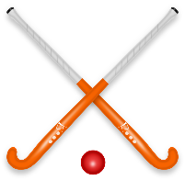
Year 5 and 6 Hockey Club

Dear Parents/Carers,
I am planning to re start the after school hockey club for Year 5 and 6 children from Tuesday 15th January 2019. The hockey club will provide the children an opportunity to develop their basic hockey skills and gain match experience. We shall be using wooden sticks that have been designed for use by primary school players and will focus on the England Hockey recommended games of Quicksticks and In2Hockey.
Due to the nature of the game of hockey, all children who wish to play must wear a gum shield (mouth guard) and shin pads. It is also recommended that they wear gloves to protect their hands.
The club will play on a Tuesday after school on the school playground from 3.30pm to 4.15pm. Hockey is normally played on astro-turf and I am hoping that we can hold some club sessions at St Crispins so that the children can get experience of playing on this surface. Details of this will be sent to you when the sessions have been booked. Children that attend the club may be picked for the school teams that play at tournaments and at inter-school matches.
Please complete the slip below if you would like your child to join the club. Please note that places are limited and will be on a strictly first come basis.
Regards
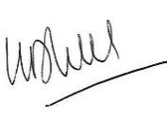
Mr B Hill
Year 5 and 6 Hockey Club
I give permission for …………………………………………………………………(child’s name) of …………….(class) to join the after school Hockey Club held each Tuesday.
I confirm that I will collect my child at 4.15pm.
I understand that my child will only be permitted to play if they are wearing a gum shield and shin pads.
Please detail any health issues …………………………………………………………………………………………………….
……………………………………………………………(Parent’s signature)
…………………………………………………………….(Parents name)
Please return this slip to Mr Hill via your class teacher. Thank you.

