Basic Facts Activities
Many of these activities can be adapted for addition and subtraction
Teaching times tables should be like building a house – you need to start with the foundations! Teach your children the simplest tables first and save the harder ones (e.g. 7s, 8s, 12s) for the end. Two times tables are a good starting point, they’re pretty straightforward as they just involve doubling each number. 10s are simple too, as they just involve adding a zero to the number you’re multiplying by 10. Once they’ve mastered the basics, your child’s newfound sense confidence will help them conquer the more difficult tables. | Use Post-it notes around the house to help remind children of the times table they are learning. A good place is to put them on the wall up the stairwell so your child can recite them every time they go up or down stairs. They should then learn to skip-count forwards and backwards! | 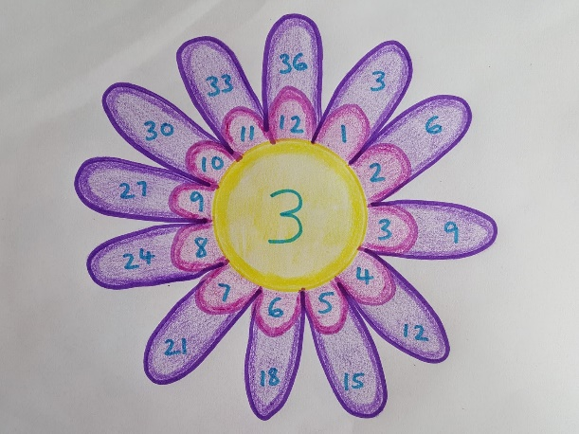  Children start this activity by drawing the centre of the flower, in which they write a number between 2 and 12. They then draw 12 petals around the centre, with each petal containing the numbers 1 through 12. The last step is to draw another set of 12 petals which contain the centre number multiplied by each petal in the inner circle. |  | Use a variety of language when asking questions. e.g. ask for the product of 2 numbers instead of multiplying them or ask for the total or sum instead of add. Click here for a poster of mathematical terms.  Alternatively, children could design and create their own poster showing these terms
 | Look for opportunities around the local area. Ask children to multiply, add or subtract digits on a number plate or on a house. They could also try to identify factors of numbers e.g. 12 has 1,2,3,4,6 and 12 as factors.
Multiplication War  The game is simple, two players draw a card from a deck. They then flip their cards over and the first person to correctly guess the total of the two cards multiplied together gets to put the cards in their winning pile. For example, if a 3 of hearts and a 7 of diamonds are flipped over, the first person who says 21 gets to keep the two cards. The person with the most cards in their winning pile at the end of the game wins. | One of the great things about maths is that it’s full of tips and tricks – and times tables are no different. A favourite trick involves using your fingers to figure out nine times tables. Start by spreading all 10 fingers in front of you. To figure out 9×1, put your left pinky down. What are you left with? 9 fingers! For 9×2 put your left ring-finger down. What are you left with? 1 finger and a gap followed by 8 fingers or 18. This trick works up to 9×9 (8 and 1 or 81). That said, when teaching children these tricks, encourage them to ask why these techniques work and the mathematical reasoning behind them. |  | What’s a great way to get information stuck in someone’s head? Catchy music! We recommend checking out videos made by Youtuber, Mr.DeMaio, an American elementary school teacher who uses clever parodies of pop songs to teach kids their times tables. Our favourite is definitely his cover of Bruno Mars and Mark Ronson’s song Uptown Funk which aims to teach children their three times tables.
Useful website links: https://www.whizz.com/blog/fun-ways-to-teach-times-tables/

