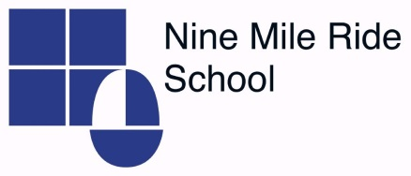
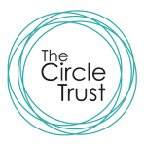
Consultation on proposed Admission Arrangements
for
Nine Mile Ride School for entry into Reception from
September 2020

Introduction

Nine Mile Ride School is an academy school and is its own admission authority, forming part of the Circle Trust. When an admission authority wishes to make changes to their admission arrangements they must consult to ensure all views are heard. The Circle Trust is consulting on the following changes to the admission arrangements for Nine Mile Ride School:

Proposed changes to the oversubscribed criteria:

- Change the order of our oversubscription criteria to consider those siblings of children in our school before those living within the designated area of the school

- Include children of staff of Nine Mile Ride School

- Revise the Looked After Children criterion to include children previously in state care outside of England

Why are we proposing these changes?

As Nine Mile Ride has become more popular in recent years, families well known to the school have been disadvantaged as they are unable to secure a place for a younger sibling. As a school rooted in the community, we wish to continue our work our families who have older siblings at the school but live further away from the school. Therefore we wish to change our oversubscribed criteria in relation to siblings.

The school wishes to retain and recruit the very best teachers for our students, to deliver high quality lessons and support. However the recruitment and retention of staff is increasing difficult against a backdrop of a national shortage of teachers. To help attract skilled and knowledgeable staff to key positions and to retain staff for the medium to long term, we wish to add children of staff to our oversubscribed criteria.

Recent Government guidance has asked all admission authorities to consider including children previously in state care outside of England in their Looked After or Previously Looked After Children criterion and we wish to fully support this request.

Copies of the proposed arrangements can be obtained from the Nine Mile Ride School office or downloaded from their website http://www.ninemileride.co.uk

How can you respond?

We would like to hear your views on these proposals. Please send any comments regarding the above proposed changes by emailing to: consultation.education@bracknell-forest.gov.uk
Please mark your email NINE MILE RIDE CONSULTATION

The consultation takes place between 1st October 2018 and 26th November 2018

What happens next?

After the consultation closes the responses will be collated and presented to the Admissions Committee at The Circle Trust who will decide whether or not to proceed with the proposed changes and determine the admission arrangements. The outcome will be published on our website by 15 March 2019.

