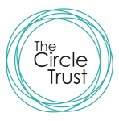
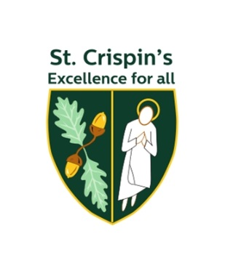
Consultation on proposed Admission Arrangements
for
St Crispin’s School for entry into year 7 from
September 2020

Introduction

St Crispin’s School is an academy and is its own admission authority, forming part of the Circle Trust. When an admission authority wishes to make changes to their admission arrangements they must consult to ensure all views are heard. The Circle Trust is consulting on the following changes to the admission arrangements for St Crispin’s School:

Proposed changes to the oversubscribed criteria:

- Change the order of our oversubscription criteria to consider those siblings of children in our school before those living within the large designated area of the school

- Include children of staff of St Crispin’s School

- Revise the Looked After Children criterion to include children previously in state care outside of England

In addition we will be admitting 200 children into year 7 from September 2020; this is 11 more children than previously to accommodate as many children as our building will allow.

Why are we proposing these changes?

As St Crispin’s has become more popular in recent years, families well known to the school have been disadvantaged as they are unable to secure a place for a younger sibling. As a school rooted in the community, we wish to continue our work our families who have older siblings at the school but live further away from the school. Therefore, we wish to change our oversubscribed criteria in relation to siblings.

The school wishes to retain and recruit the very best teachers for our students, to deliver high quality lessons and support. However, the recruitment and retention of staff is increasing difficult against a backdrop of a national shortage of teachers. To help attract skilled and knowledgeable staff to key positions and to retain staff for the medium to long term, we wish to add children of staff to our oversubscribed criteria.

Recent Government guidance has asked all admission authorities to consider including children previously in state care outside of England in their Looked After or Previously Looked After Children criterion and we wish to fully support this request.

Copies of the proposed arrangements can be obtained from the St Crispin’s School office or downloaded from their website https://www.crispins.co.uk

How can you respond?

We would like to hear your views on these proposals. Please send any comments regarding the above proposed changes by emailing to: consultation.education@bracknell-forest.gov.uk
Please mark your email ST.CRISPIN’S CONSULTATION

The consultation takes place between 1st October 2018 and 26th November 2018

What happens next?

After the consultation closes the responses will be collated and presented to the Admissions Committee at The Circle Trust who will decide whether or not to proceed with the proposed changes and determine the admission arrangements. The outcome will be published on our website by 15 March 2019.

