Annual Governors Report
For the academic year
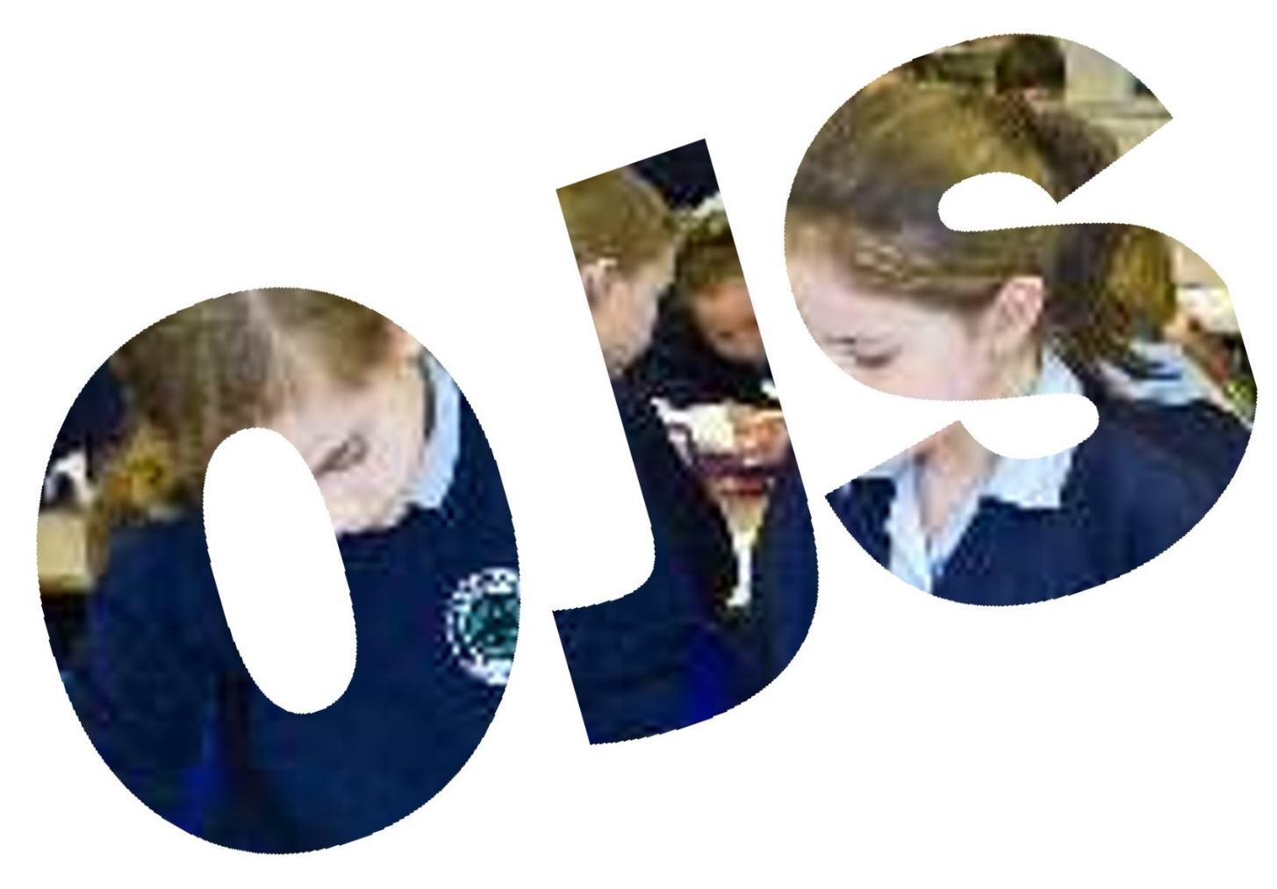
2017-2018

Contents

Chair’s Introduction Page 3

School Aims Page 4

How do school leaders and governors promote school improvement? Page 4

Our Governing Body Page 5

Governors’ links with specific areas of the curriculum Page 5

Finance and Premises Committee Report Page 6

Staffing Committee Report Page 7

Curriculum Committee Report Page 8

School and Community Report Page 9

Chair’s Introduction
Welcome again to another Annual Report of the Governing Body of Oaklands Junior School. I have had the privilege of continuing my role as the chair of the governing body and enjoying the close links that we, the governors, have with the staff, children and parents at school. I am pleased to say that Oaklands has enjoyed another successful year and continues to go from strength to strength.
After more than a year of planning, January this year saw us converting to academy status and being one of the founding schools of the Corvus Learning Trust, we are all looking forward to benefits it brings to us.
Following on from our Ofsted inspection last year, everyone has been working hard in raising standards throughout the school, this was reflected in our School Improvement Officer’s visit and report that stated “Oaklands Junior School is a good school with some developing practices which should lead it to being an Outstanding School at the next inspection”.
This report outlines our successes and achievements and I hope that you will take time to read the report. We continue to build on our strong community links and help develop our children to becoming good citizens. I think we are extremely fortunate at Oaklands to have created such a positive and vibrant environment in which our children can learn.
Since I joined the governing body in 1999 I’ve worked with four headteachers, the school has had five Ofsted inspections, seen very little change to the teaching staff (apart from retirements and maternities) and most recently become an academy. As I retire from the governing body it is time to move on to the next chapter of my life, I have thoroughly enjoyed the highs (and occasional lows) that the school has been through, working with both the children, staff and parents has been a very rewarding experience. I leave the governing body in ‘safe hands’ as my vice chair for many years Liz James has been elected chair for the coming year.

Finally, I must thank the headteacher, staff and governors for their on-going dedication and commitment which makes Oaklands the school that it is, a successful, happy and continually improving school.

John McLaren
Chair of Governors

School Aims
We aim to be the local school of choice through our unique Thinking Schools philosophy that equips children with important skills for life.

Learning to Think – Thinking to Learn
Developing Enquiring Minds and Creative Thinkers
At Oaklands Junior School, we value our Oaklands’ Mindset that permeates everything we do. Our whole school community will:
- Challenge self and others to reach their full potential
- Foster determination and resilience in working towards our Ambition
- Encourage greater confidence to achieve Independence
- Value Friendship that shows respect and compassion
- Promote happiness and motivation to succeed through Enjoyment
- Develop Communication through collaboration and co-operation
How do school leaders and governors promote school improvement?
At Oaklands Junior School leaders have children’s safety, welfare and learning at the forefront of all decision-making. Each member of staff and each governor is a leader of at least one aspect of the school’s life, working as a strong team to improve and raise standards. Pupil voice, through the School Council and parent consultation through meetings and surveys, mean that the whole school community is part of the consultation and decision making process.
The Headteacher and her Senior Leadership Team work with all aspects of the school community to identify priorities, plan and action developments for these and to closely monitor impact and outcomes.
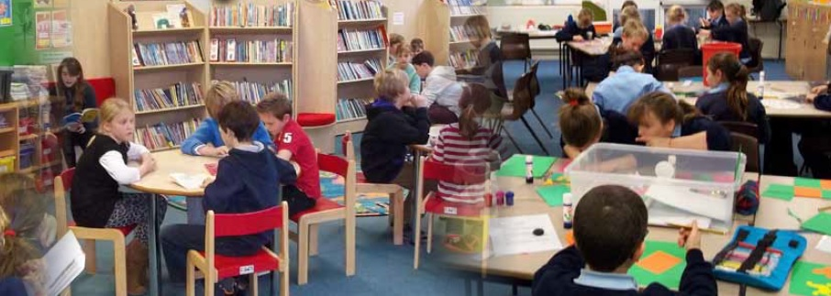
The Governing Body monitors school improvement priorities through regular visits to the school for meetings, taking part in lessons and learning walks, it also spends time on scrutiny of documentation and ensures that the Headteacher and staff are regularly and rigorously appraised. In all, the ‘Team’ ethos at Oaklands Junior School is key to the successful learning of all our children.
Our Governing Body
Name |  | Type of Governor |  | Term of  Office
Esther Blake |  | Co-opted |  | Mar-22
Roger Blake |  | Co-opted |  | Oct-21
Kevin Davis |  | Co-opted |  | Jan 22
Debby Griffiths |  | Co-opted |  | Jan 19
Duncan Holland |  | Staff |  | Oct 20
Liz James |  | Co-opted |  | Jan 19
Hiten Joshi |  | Parent |  | Nov 20
Susanne Kaps |  | Local Authority |  | Jan 22
Charlotte Kieran |  | Co-opted |  | Nov 20
Barbara Paige |  | Co-opted |  | Jan 19
Carolyn Pyke |  | Co-opted |  | Jan 19
Justine Waight |  | Parent |  | June 21
Hazel West |  | Headteacher
David Whitfield |  | Co-opted |  | Sept 20
The Governing Body and the Headteacher
share responsibility for the strategic
management of the school, acting within
the framework set by national legislation
and by policies of the LA and Corvus Learning Trust. While the Trust is the employer of staff, the Governing Body and Headteacher have
separate and particular responsibilities for
the selection and management of staff.
The internal management of the school is
the responsibility of the Headteacher.
The full Governing Body meets at least twice
a term. In addition, there are four committees that conduct the main business of the governing body, each one reporting back to the full governing body. Most of the business of the governing body is conducted by these committees. The Governing Body for our school for the forthcoming year should be as above:

Governors’ links with specific areas of the curriculum.
Subject | Governor
Mathematics | Roger Blake
English | Carolyn Pyke
Computing | Susanne Kaps
Thinking Schools | Barbara Paige
SEND & EAL | Justine Waight
Safeguarding | Esther Blake
Pupil Premium | Justine Waight
Health & Safety | David Whitfield
Development | Debby Griffiths
Prevent | Barbara Paige
Children In Care | Liz James
Art | Charlotte Kieran
DT
French | Carolyn Pyke
Geography | Barbara Paige
Global Learning | Susanne Kaps
History | Barbara Paige
Most Able & Talented | Justine Waight
Music | Charlotte Kieran
P4C | Barbara Paige
RE & PE | Justine Waight
These governors visit the school regularly to work alongside teachers in their chosen subject area. Working in this way they develop a clearer idea of how our school works, forge stronger links with teachers and develop lasting relationships with children.

Finance and Premises Committee Report
An effective learning environment makes a key contribution to helping to inspire, motivate and challenge our children. The headteacher, staff and teaching assistants create this environment but they cannot do it alone. They need the support of high quality facilities and sufficient funding to bring out the best in our children.
The role of the Finance and Premises Committee is essentially to ensure that we have strong financial management and make the best possible uses of our financial and premises resources for the benefit of our children.
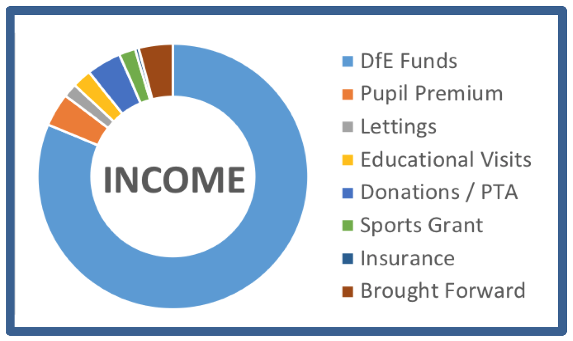
Concern over school funding is very much in the media at present but Oaklands Junior School is currently in a good position. This has not happened by chance; we are a good school that attracts families, with a capable and highly motivated staff. We also have carefully-managed facilities that support the children’s learning and a variety of interesting extra-curricular activities. The change to academy status, as part of the Corvus Learning Trust, at the start of the year has maintained our healthy budget position and has brought us greater control over how we spend our money.
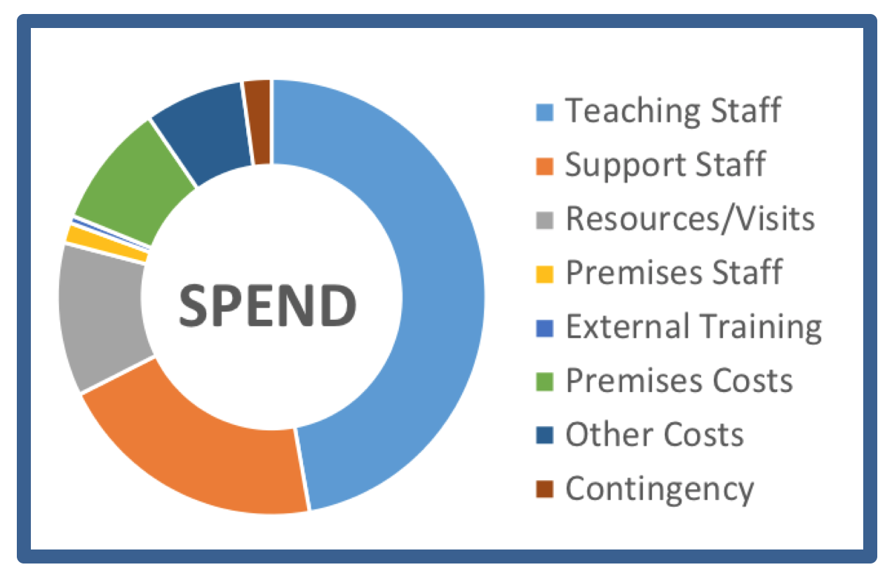
We have an annual income of around £1.1m. With a staff of 28, and in common with all schools, around three-quarters of our income is spent on staff costs. The remainder is largely spent on learning resources and on running and maintaining our buildings and grounds. Every year we also plan to run a number of projects to ensure the continual improvement of our school. This year’s projects have included a major upgrade of the IT Suite (thanks to funds from the legacy After School Club), refurbishment of the pond and a rolling decorating programme.
The school ends the year in a good position, having delivered a number of significant projects, and the outlook is good for the year ahead. This is all a tribute to the strong teamwork between the staff, governors, parents and children. Our challenge for the year ahead is to maintain and strengthen our position and, once again, we will be seeking the help of parents to achieve this.
David Whitfield
Chair of Finance & Premises Committee

Staffing Committee Report

Excellent teaching is what inspires, motivates and challenges our children during their time with us at Oaklands Junior School. The Headteacher and staff are responsible for creating the best possible learning environment, but in this they are supported by the Governing Body and, in particular, the Staffing Committee. The Staffing Committee is responsible for the appointment of both teaching and non-teaching staff, adopting and reviewing employment related policies including the Pay Policy, monitoring the professional development of staff and ensuring that the Staff Appraisal policy is implemented. The Committee is also responsible for the Headteacher’s annual appraisal.
At the start of this year, we welcomed Mrs Townend as a Teaching Assistant. At Easter, Mrs Hare-Winton retired, and we wish her a very long and happy retirement. We also said goodbye (temporarily) to Mrs Jones at Easter, as she left to go on maternity leave, but we look forward to welcoming her back next year. We will also be saying a temporary goodbye to Mrs McLaren at the end of the summer term as she will be leaving us for a year to go travelling.
Sadly, three members of staff will be leaving us at the end of the summer term: Mr Hill and Mrs Draffin are both retiring and Mrs Bugg is to train as a Baptist minister, all of whom have been with us for a number of years. They leave us with our thanks for everything they have done for the school, and our very best wishes for the future. We are very pleased that Mr Hill is not leaving us completely just yet, as he will be back in school for two days a week until Mrs Jones returns next year.
We have recently been joined by Mrs Luther as a Lunchtime Supervisor, and look forward to welcoming Miss McComish as a teacher and Mr Harris as a TA when they join us in September.
In January, we joined the Corvus Learning Trust, which represented a change of employer for all our staff. I am pleased to report that the transfer went as smoothly as could be hoped, and had minimal impact on staff.
We are so lucky at Oaklands Junior School to have a fantastic team of dedicated, talented and committed teaching and support staff throughout the school who work hard to create a positive learning environment in which the children are encouraged to achieve the best they can. We are committed to maintaining the quality of teaching and support in the school despite the increasing financial constraints.
The Staffing Committee will continue to do whatever it can to support the Headteacher and staff so that they can continue to deliver an excellent learning experience for the children and consistently high pupil attainment.

Carolyn Pyke
Chair of Staffing Committee

Curriculum Committee Report

The Curriculum Committee is responsible for ensuring that the school delivers a broad and balanced curriculum in line with Government guidelines as well as monitoring assessment arrangements and evaluating results. In order to fulfil these obligations, we meet 4 times a year and report back to the Full Governing Body on all curriculum-related issues, including the progress of those with special educational needs, those receiving pupil premium and the most able and talented.
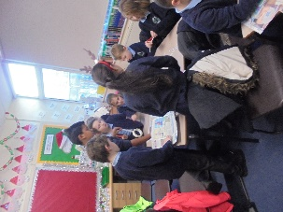
However, Oaklands Junior School believes that a child’s education should be more than academic success, and this can be evidenced in the wide range of extra-curricular activities that are offered as well as our belief that the ethos of becoming a Thinking School will help the children become confident and enquiring learners. Indeed, the Thinking Days that have been held this year have seen the children mixing brilliantly with children in all year groups, thereby enhancing their social skills and learning from each other. We hope that all the work that has been put in by the staff, all of whom are fully committed to this programme, will lead to our formal accreditation this year.
This year saw the formation of the Corvus Learning Trust, which we are confident will bring great benefits in terms of the curriculum. It is already leading to far more cooperation with Oaklands Infant School and Edgbarrow, with more liaison on both assessment and subjects, which should result in easier transition between the various schools. Even though the majority of our children do go to Edgbarrow however, this does not mean that the other children are disadvantaged in any way, as there will be no difference in terms of teaching etc.
We continue to focus on improving Writing within the school, and were pleased to see that last year’s SATs results did see an improvement in this area.
Governors do make a point of seeing the school in action, rather than just relying on reports and results, and we do spend time going into lessons and talking with staff and children about what they are doing. We look forward to continuing to work with Mrs West and the staff to ensure that the children at Oaklands Junior School receive a challenging and exciting curriculum, which will prepare them both for the next stage of their education and for life in general.
Liz James
Chair of Curriculum

School and Community Committee Report
The School and Community Committee is primarily concerned with the well-being of all pupils within our school community at Oaklands , ensuring that every child is given an equal opportunity to enjoy the best education possible in a safe and caring environment. We aim to respect the rights of every individual, whilst also making each individual aware of the responsibilities they hold towards each other and the larger community. The philosophy embodied in our vision of ‘Learning to Think, Thinking to Learn’ and in the Oaklands Mindset, is fundamental to everything we do.
Safeguarding is of paramount importance; we ensure that our policy and staff training are always up-to-date and in-line with current statutory guidance and that any safeguarding issues are properly recorded and reported and appropriate action taken. We also maintain and review policies on behaviour, anti-bullying, equality, accessibility etc, in order to ensure an environment of tolerance, caring and fairness in school.
The relationship between home and school is crucial and we are constantly striving to ensure timely and effective communications with parents through the website, newsletters and information evenings. The school website is our main line of communication to parents and prospective parents; it has recently been relaunched and will continue to evolve. We conduct an annual Parent Questionnaire to give parents the opportunity to register their views on various aspects of school life and their child’s education. We were disappointed in the low response rate this year, only 46 being returned, but there were still many useful comments for the staff and governors to take account of. The findings of this questionnaire are shared with the staff, governors and parents.
The pupil ‘voice’ is heard through the School Council and also in a Leavers’ Questionnaire undertaken by pupils at the end of year 6. This year the School Council requested playground gym equipment and all the children took part in a vote to select the items of equipment that they would like to have. Through money raised from the Tesco ‘Bags of Help’ and the Waitrose ‘Community Matters’ schemes, we are now in a position to proceed with this project and hope to have the equipment installed before September of this year.
We are also concerned about the relationships the school and its pupils have within the local community, including our links with the Infants School, Acorn Unit and After School Club, the Corvus Learning Trust, other local schools and organisations and events in Crowthorne, Wokingham and beyond. To strengthen our working relationship with the Infant School, we aim to work more in unison wherever possible; staff are working more closely on curriculum matters to enable an easier transition for pupils; inter-school visits, such as Infant School children watching Junior School play performances, are taking place, and joint events for both schools have been organised, such as Sports Day and the Royal Wedding picnic. At Governor level, Kevin Davis is a Governor at both the Infant and Junior Schools.
Oaklands School children take part in a wide variety of local and inter-school events, including many sports fixtures, but also the Berkshire Music Festival, Maths Competitions, Crowthorne Late Night Traders and Crowthorne Carnival and we like to share many of their activities and achievements in articles featured in the Crowthorne Eye. This year we included articles on Osmington Bay, the Big Red Bus and an interview with Mr Bob Elsey, highlighting our recent conversion to an academy, Corvus Learning Trust, of which Mr Elsey is CEO.
Barbara Paige
Chair of School and Community

